**Note: before exucte ./DFS_client [hostname] or ./DFS_server. Make sure both directory can w/r or both are sudo. Also windows may result in extra .txt extension.**

Detail demo below:

First type make to make everything. Then

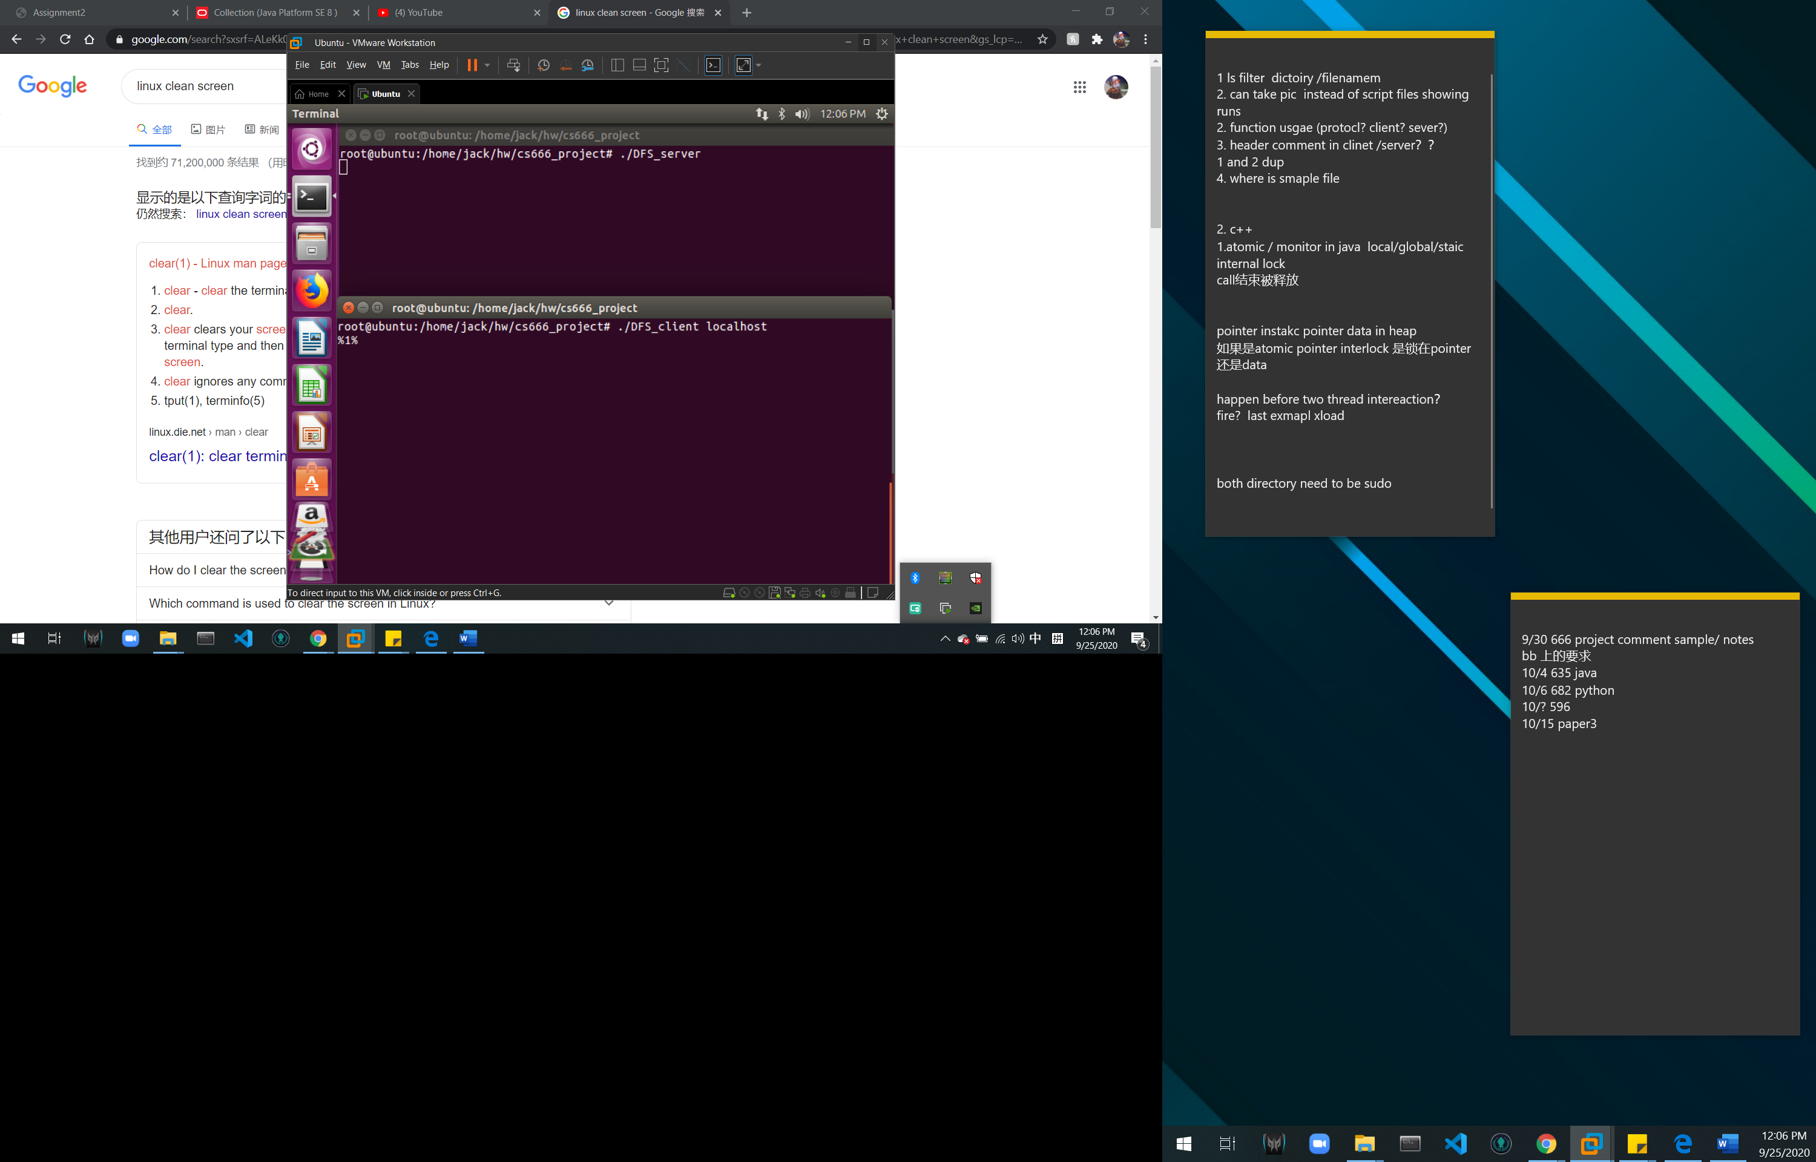

The prompt with line number indicate how many command has excuted.

Lest file is here

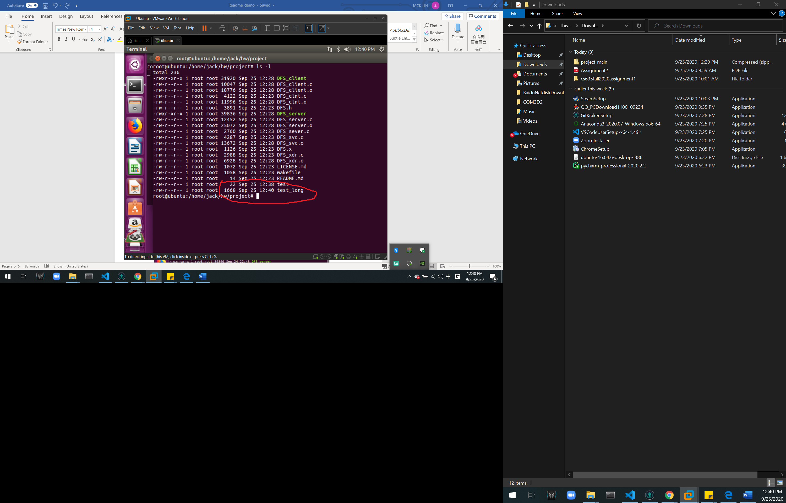

test is 22 bytes and test_long is 1668 bytes

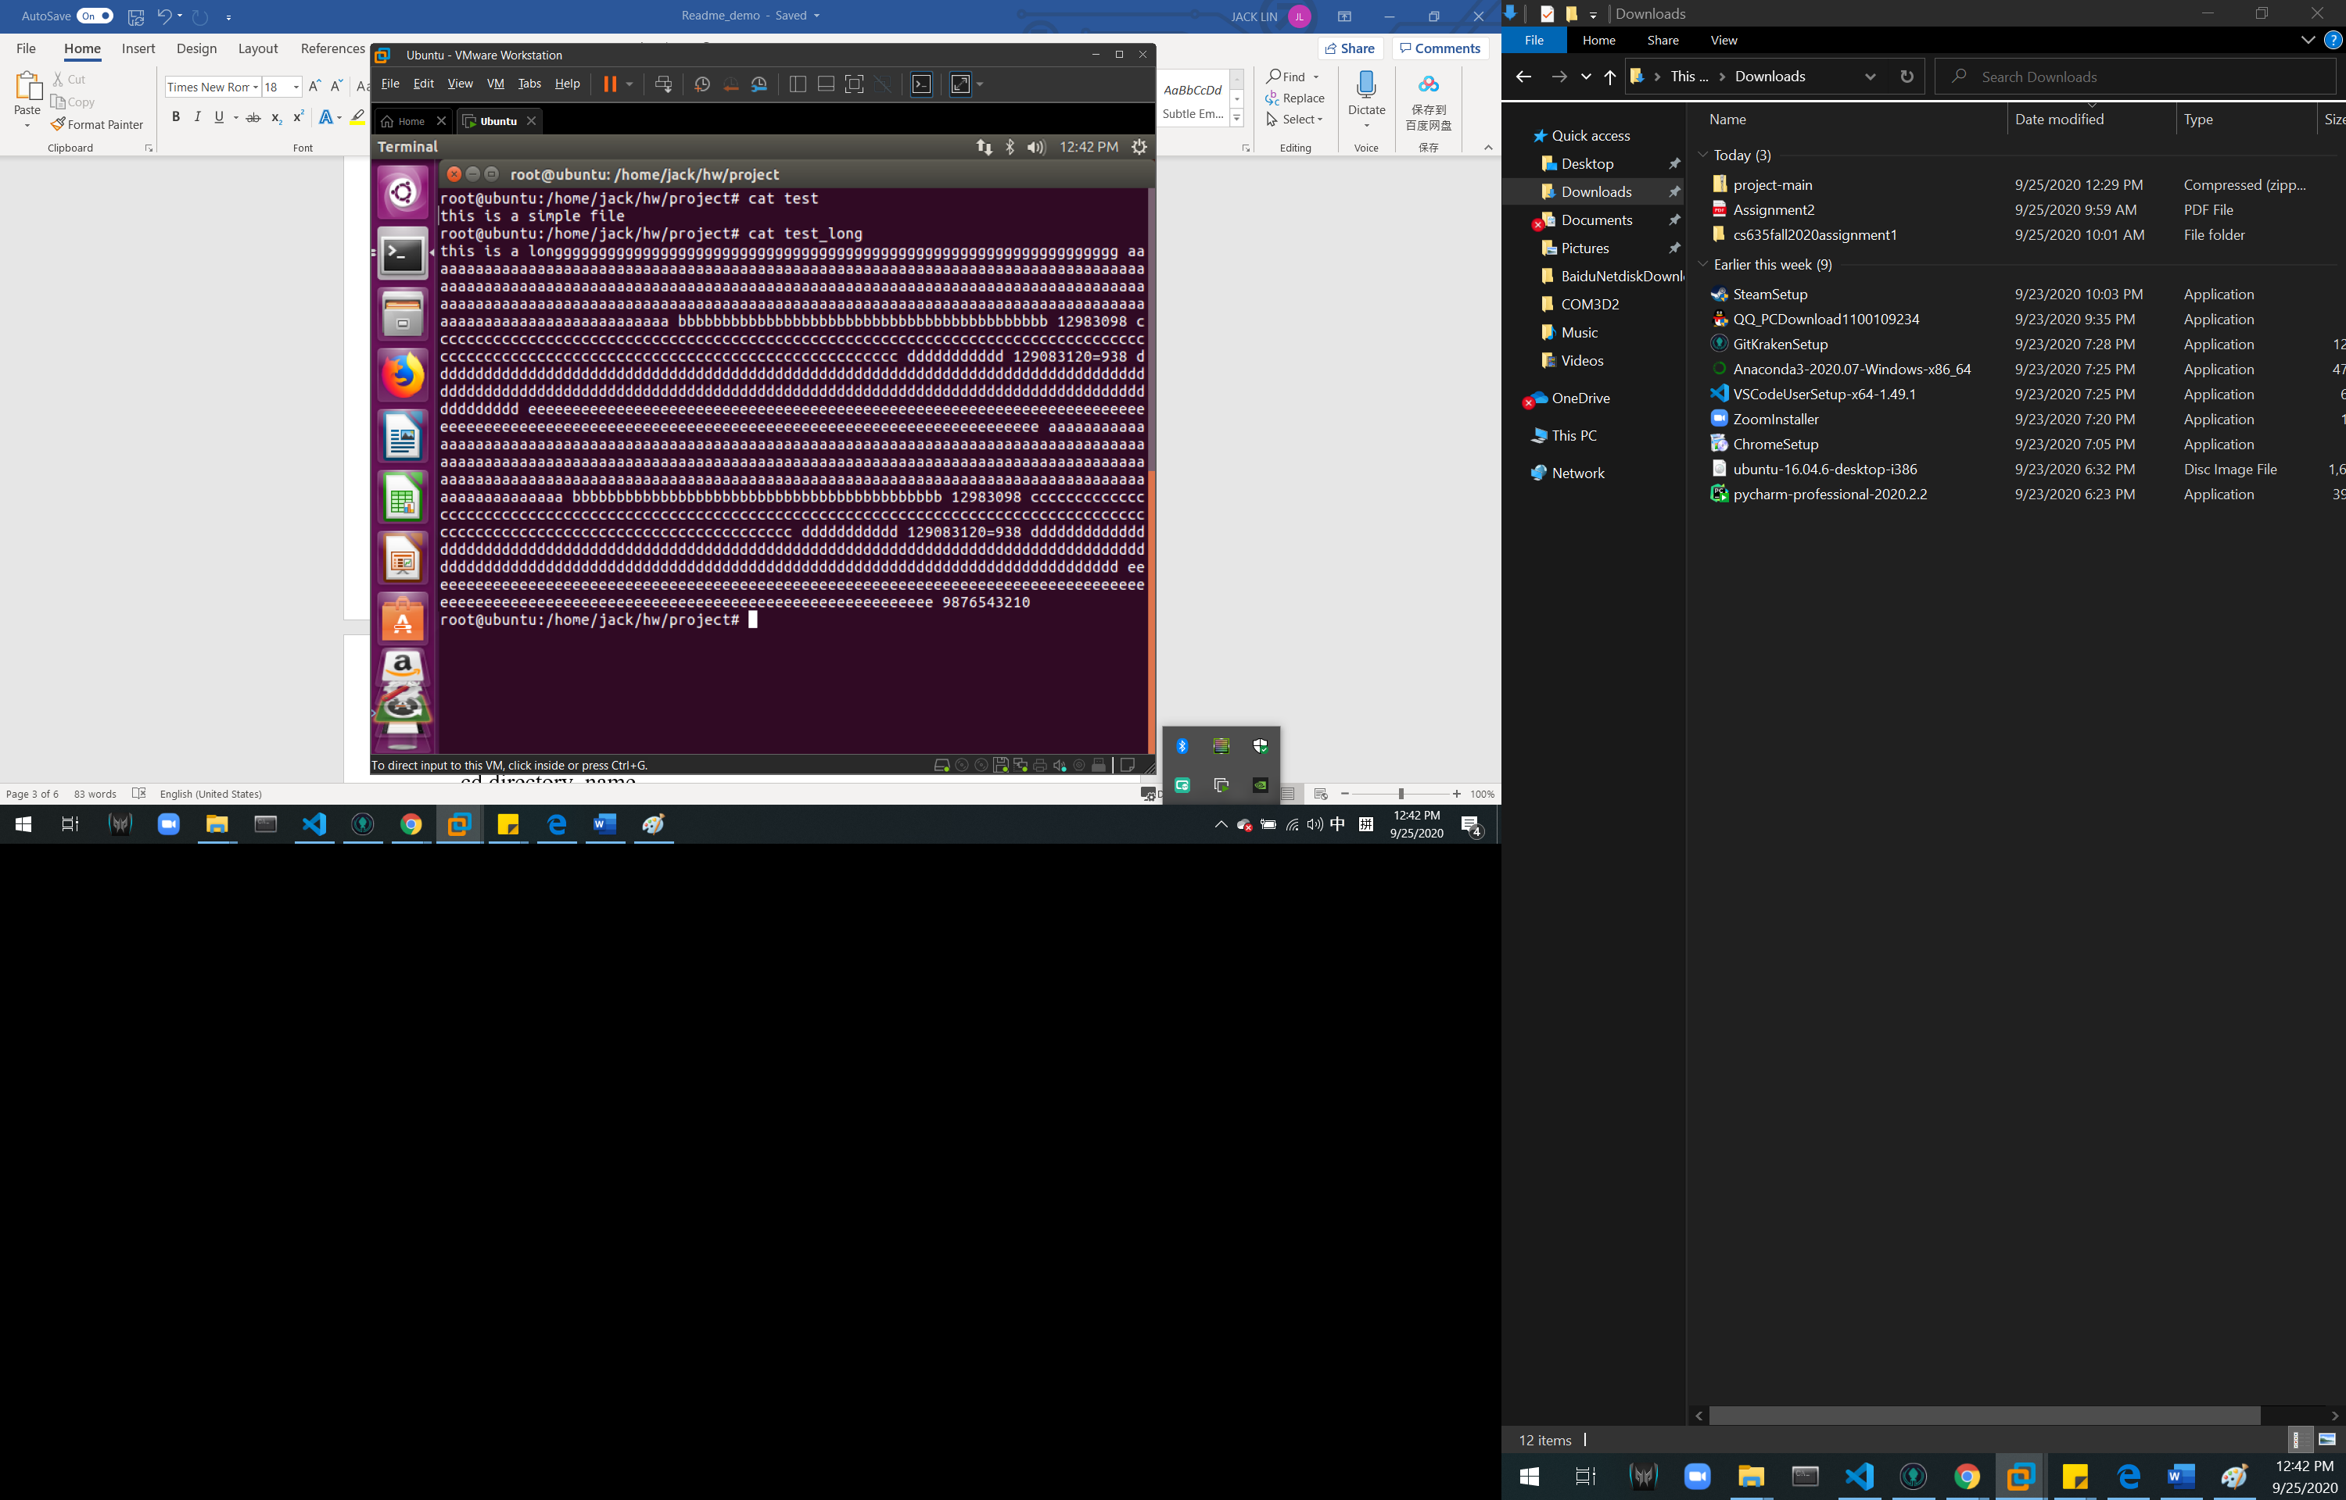

getdir

cd directory_name

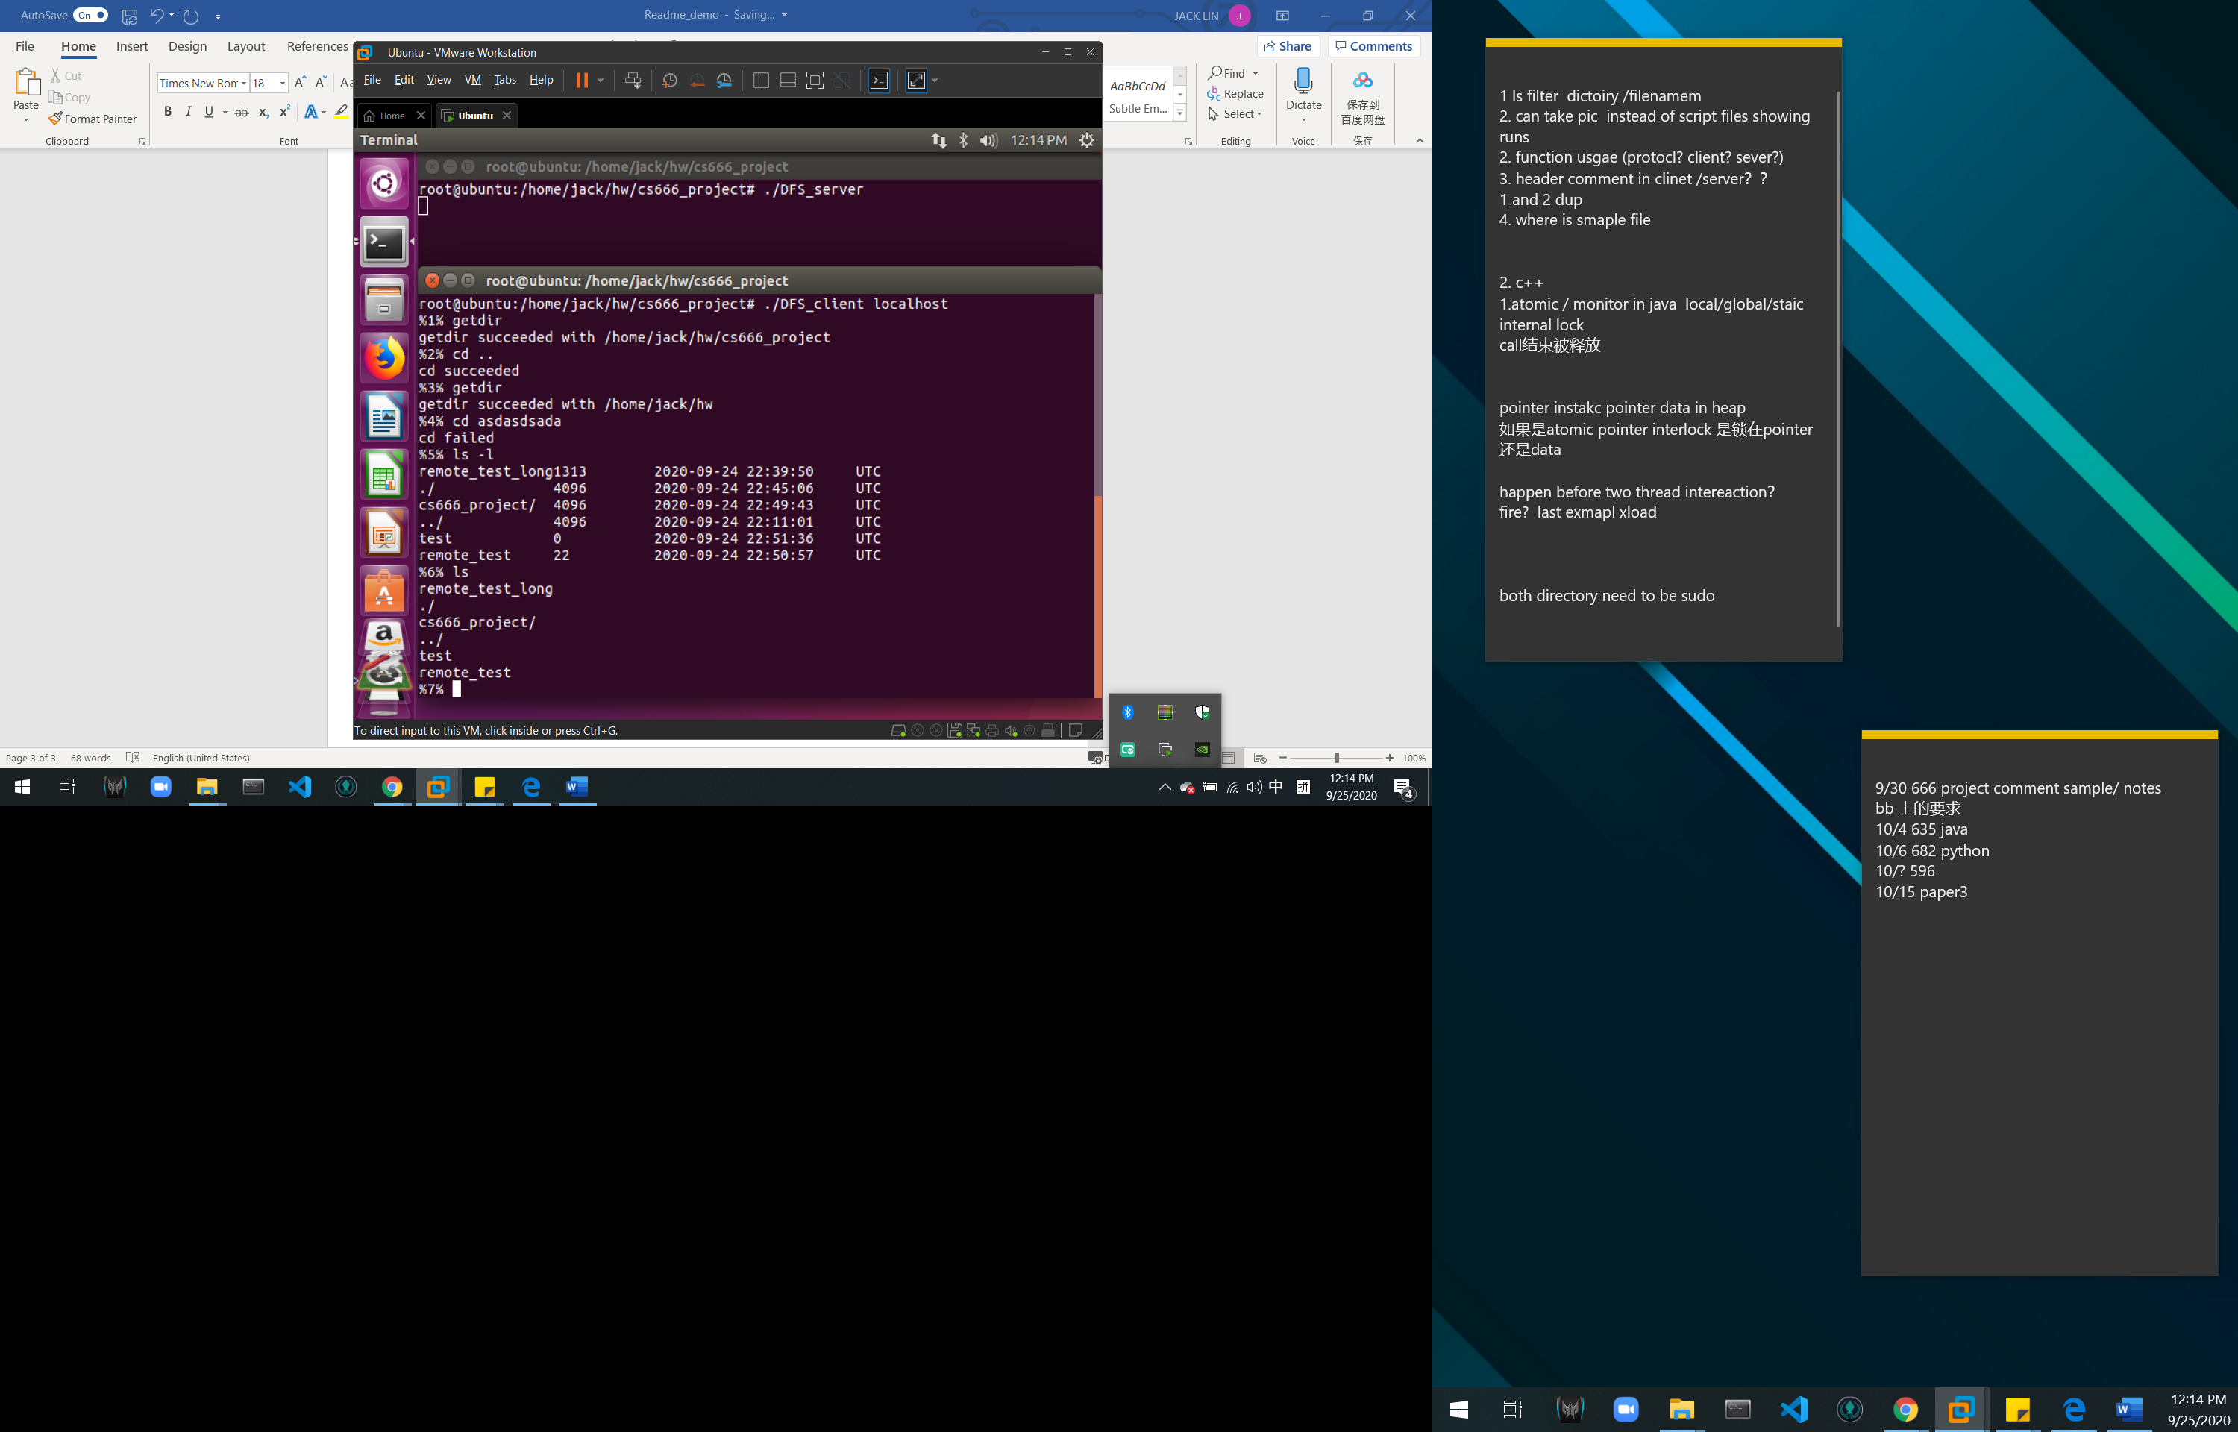

ls (-1/conditions) [directory_name]

(notice here I modified test remote_test file for testing reason

Also this from another directory)

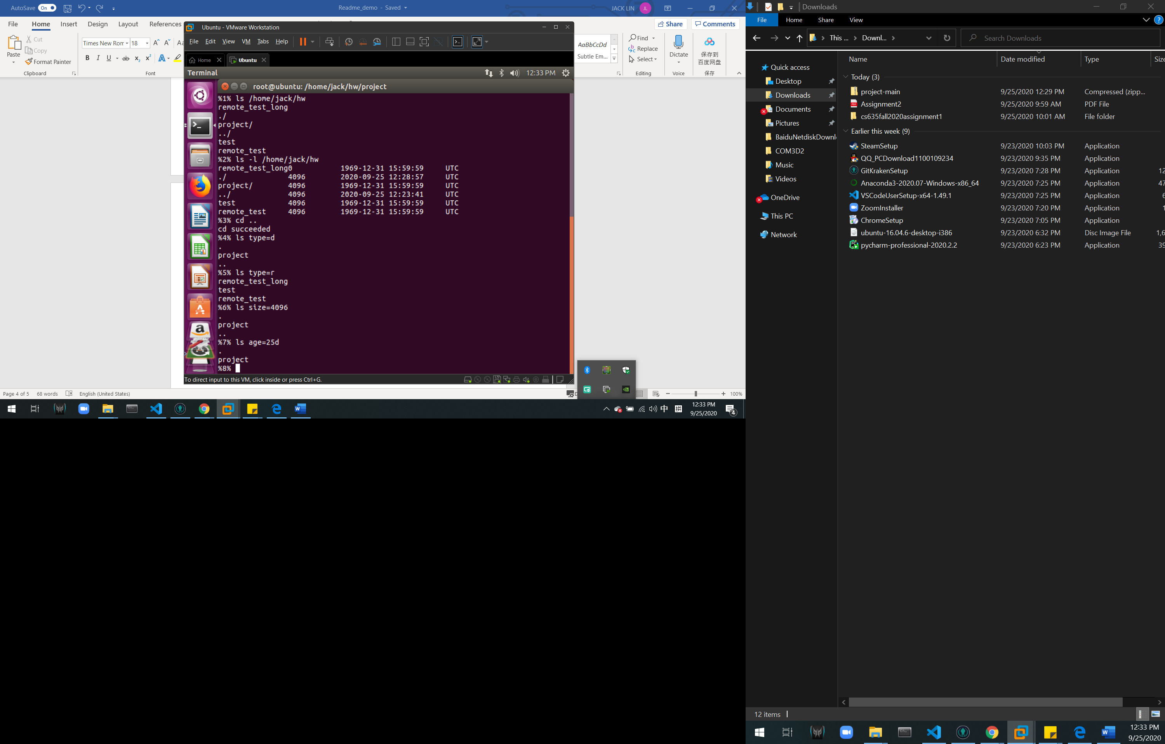

filecount (conditions)

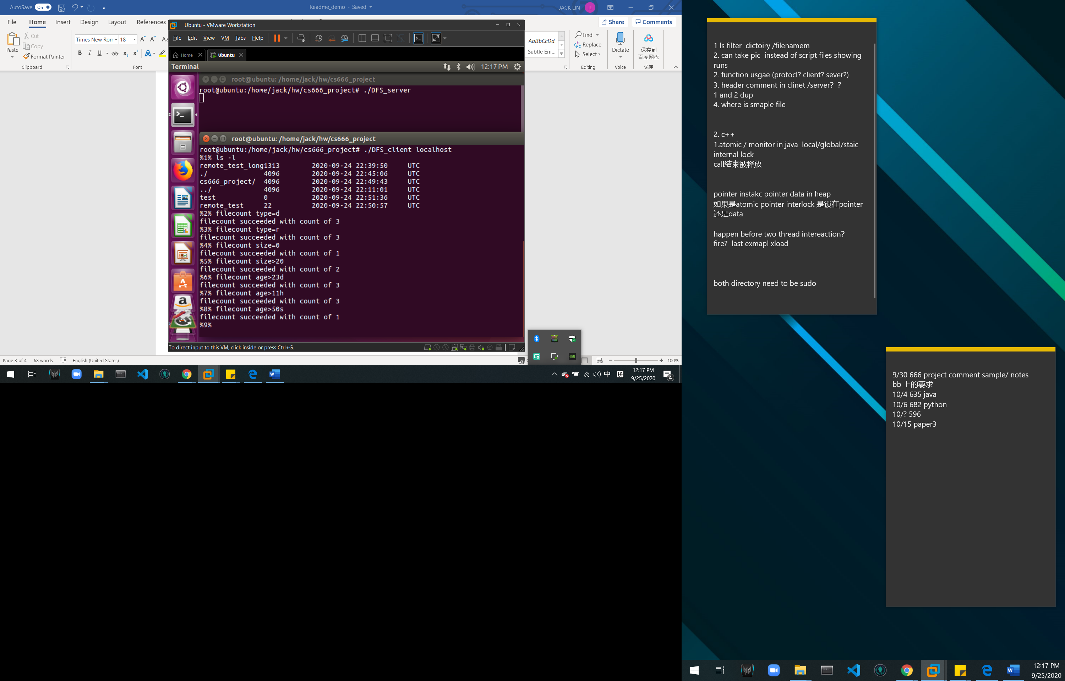

put local remote

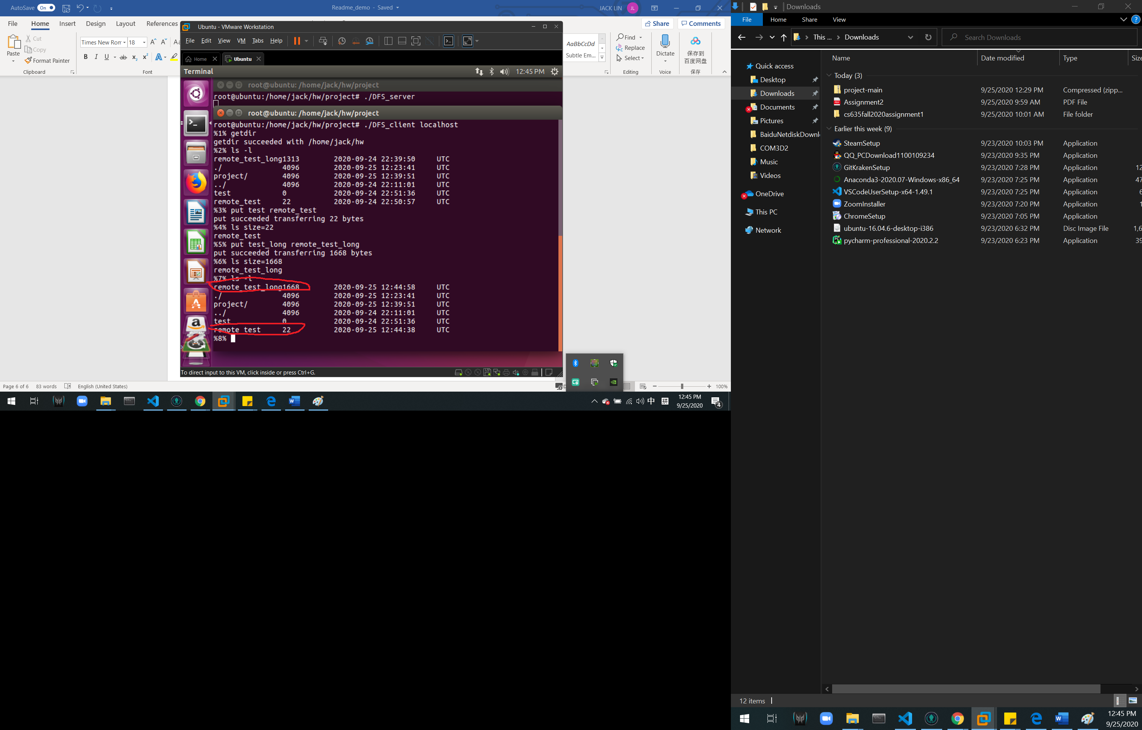

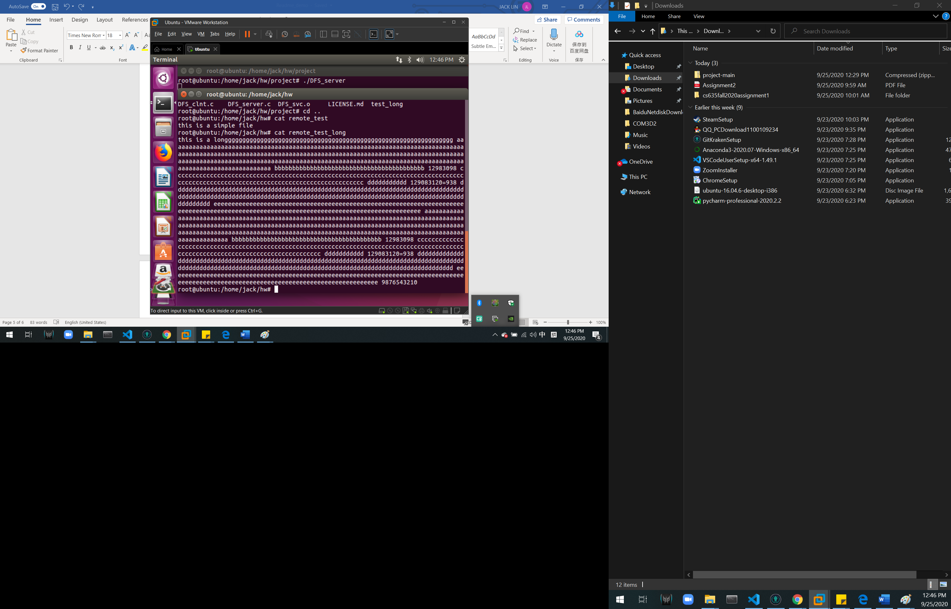

get remote local

(create empty filename at local directory in this case is get_test, and get_test_long. If filename same will overwrite)

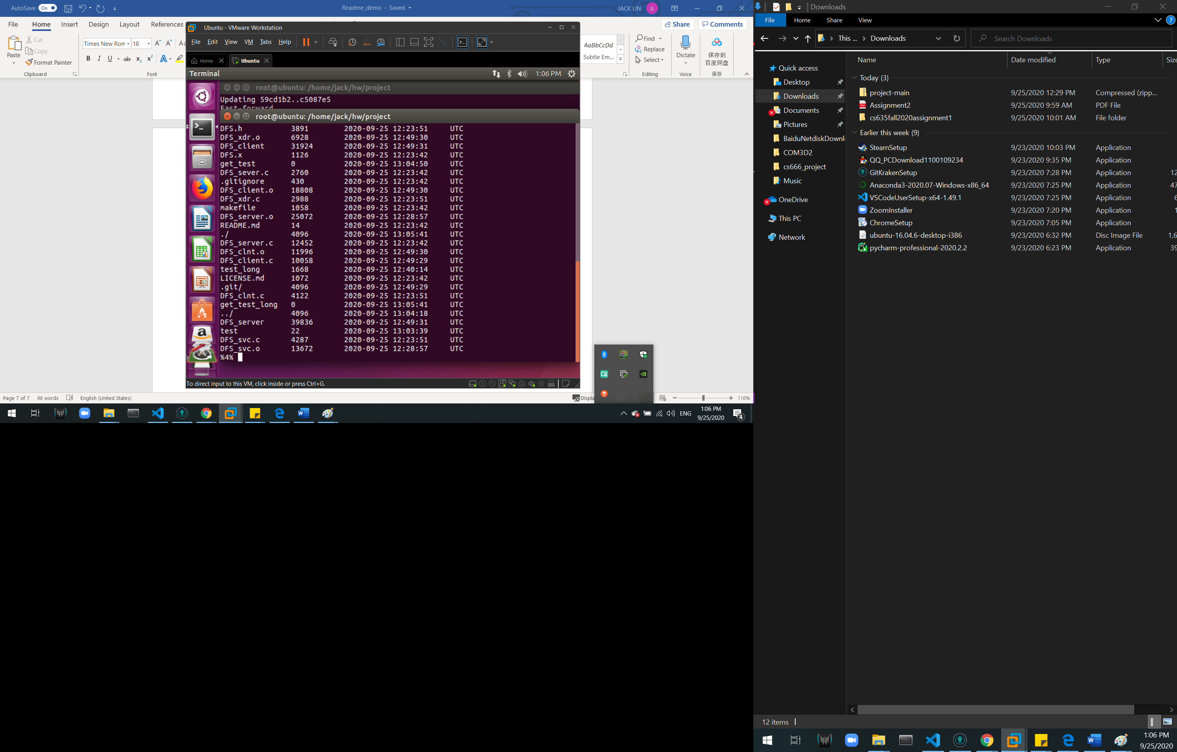

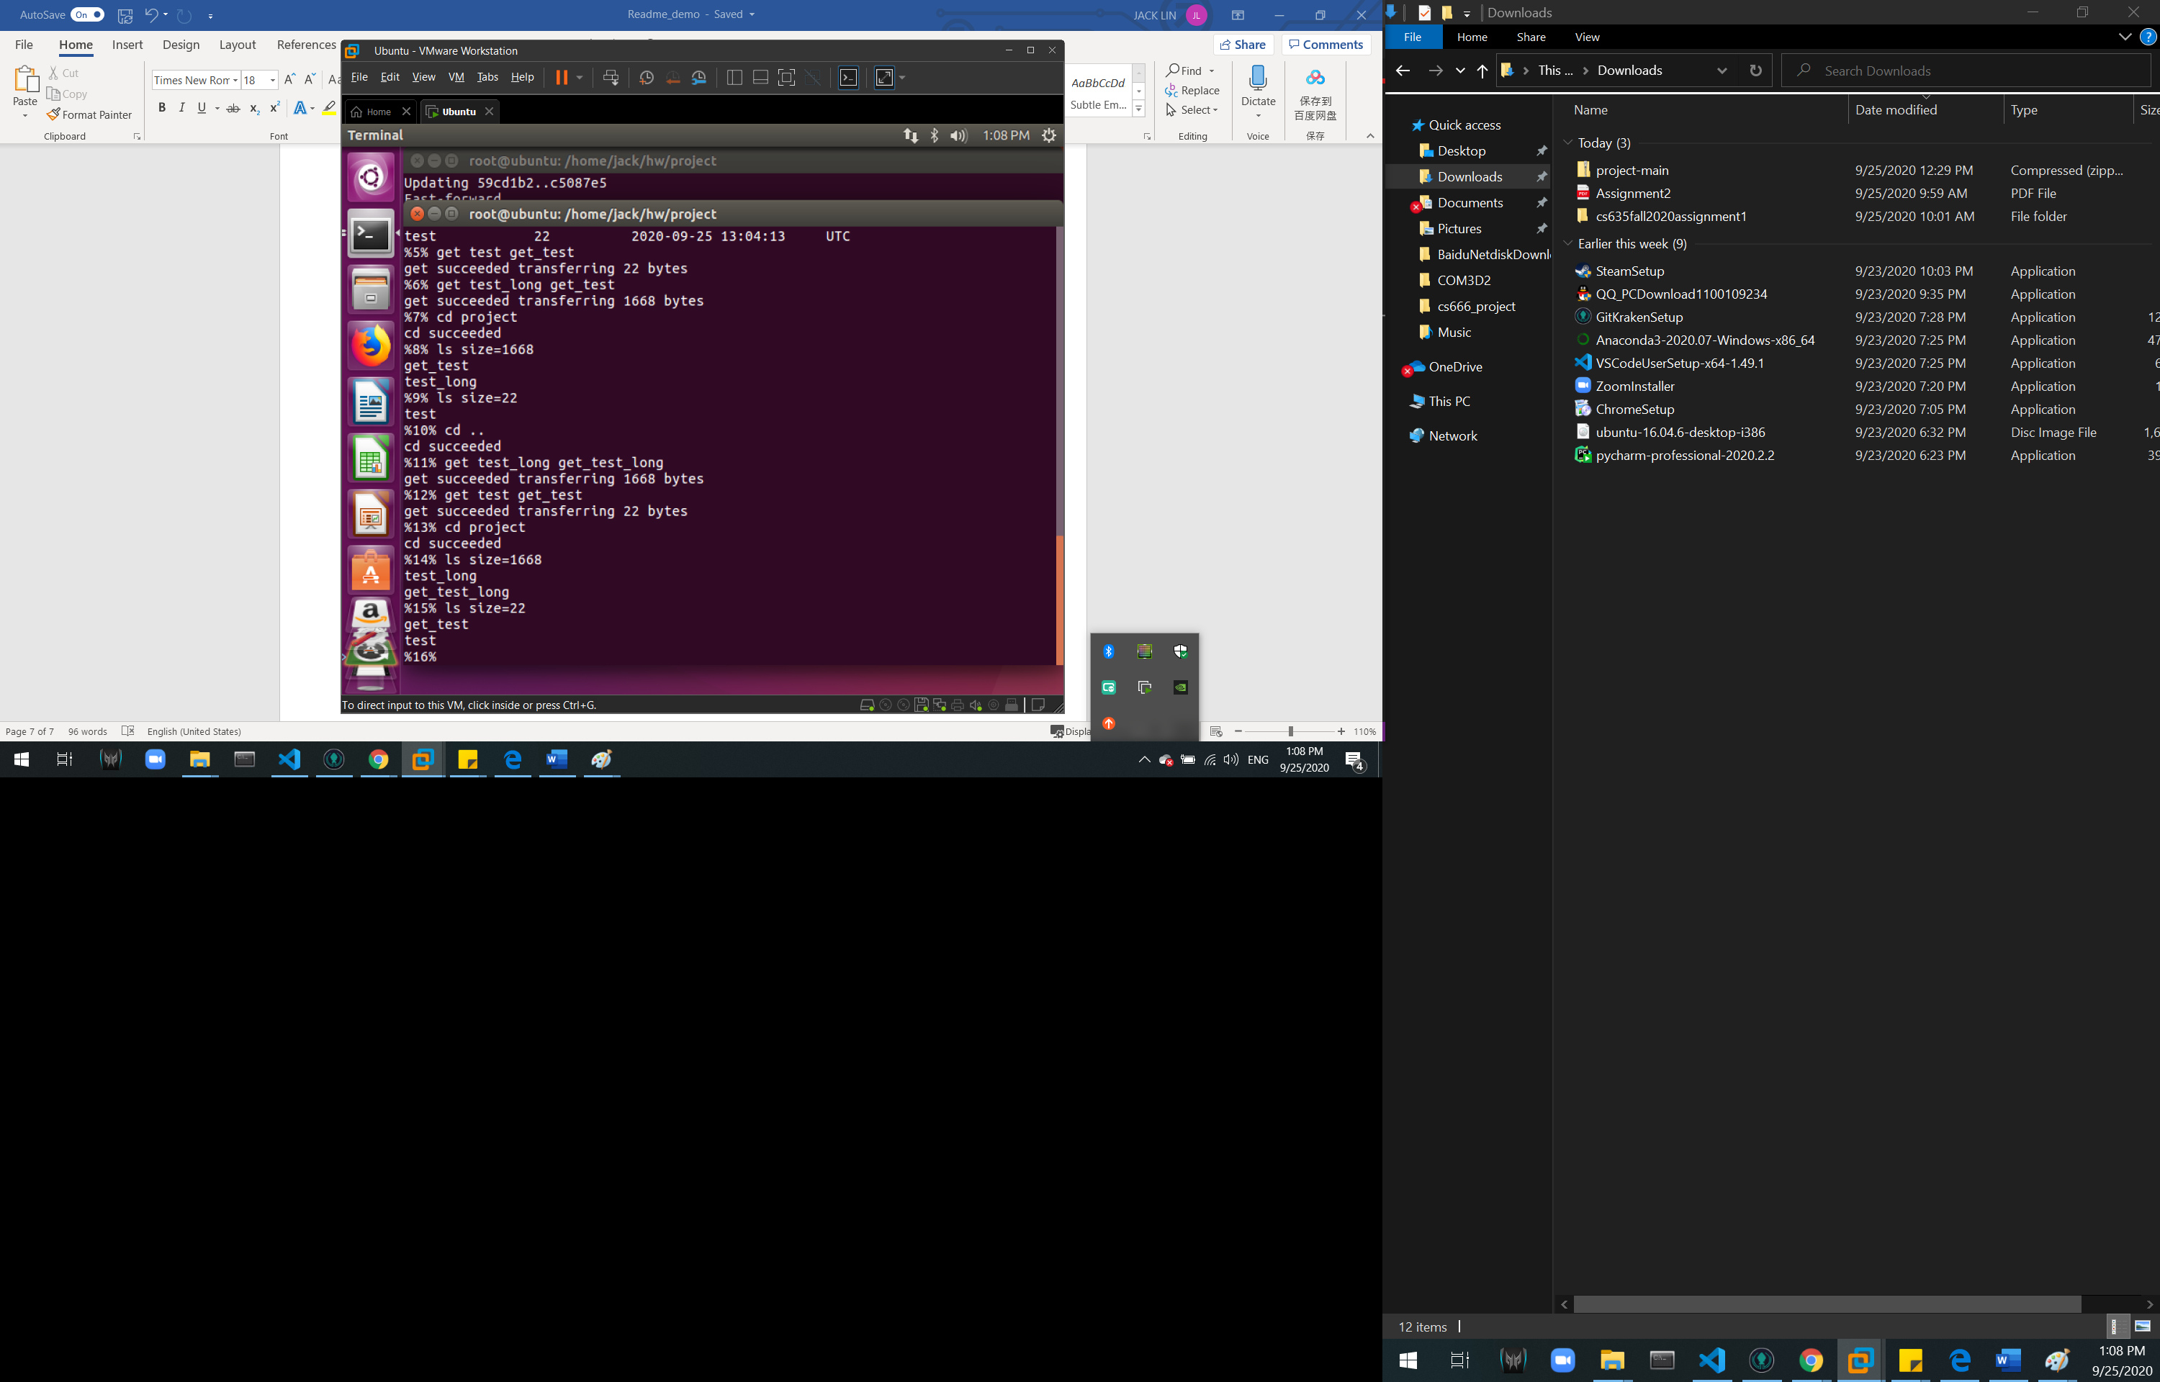 q

randomread [filename][start] [size]

